SMART EATING – FOOD GUIDE

# Introduction

Smart Eating is an android/web application which is used to find the recipes and search restaurants based on his choice. The user can get a list of recipes based on the keyword he gives and then by selecting a recipe, he can get a list of ingredients which are used to make a recipe and the process of preparing it.

The list of restaurants is obtained based on the location and food item given by the user. From the resultant restaurants, user can get menu and reviews. The user can also add his personal review.

A person might have allergic reaction towards few food items like peanuts, milk, eggs, etc. and he must be very careful while consuming the food. Hence, this application provides the user to add items which are allergic to user so that the application can highlight the items which are allergic to him. Thus, the user can differentiate what to eat and what not to.

The application smart eating also provides an option for translating the text for travelling users so that they can know each item in detail.

# Objectives

The main goal of the project is to develop a smart eating system which initially allows the user to find a restaurant by selecting a location, range of miles within which the restaurant should be searched, type of the restaurant which can be selected from a dropdown menu containing the details like Mexican, Chinese, Italian, Indian. Then the user can select all the allergies he has towards food and also the diseases he has.

A list of restaurants is populated based on the search criteria. Menu of the selected restaurant is then displayed which contains the details of all the food items and also it will suggest the user whether the food item contains the ingredients that are allergic to user and also if the item is healthy or not based on his diseases.

# Project Deployment:

## Android Application:

User Registration:

In this page, user can enter his/ her credentials into our application in order to sign up and all the details will be stored in the online mlab database (mongo dB).

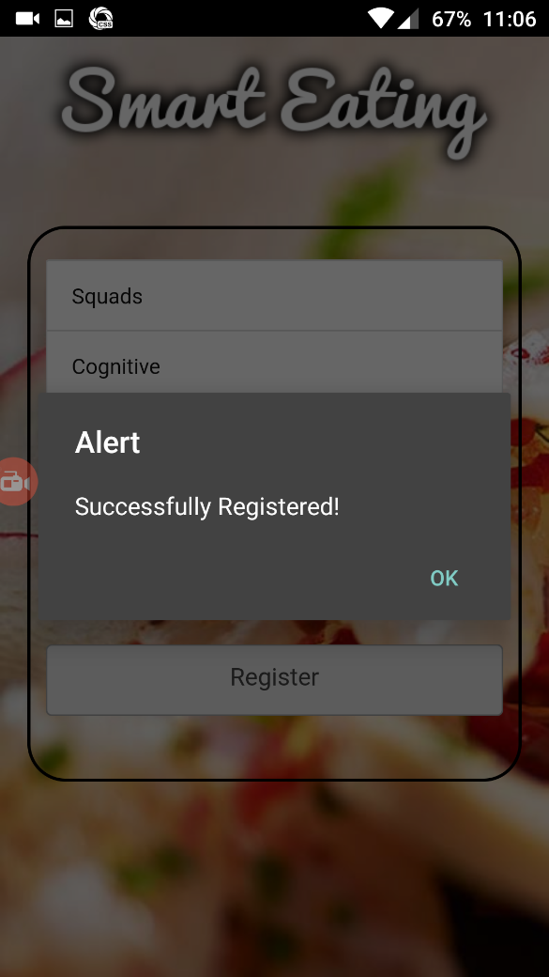

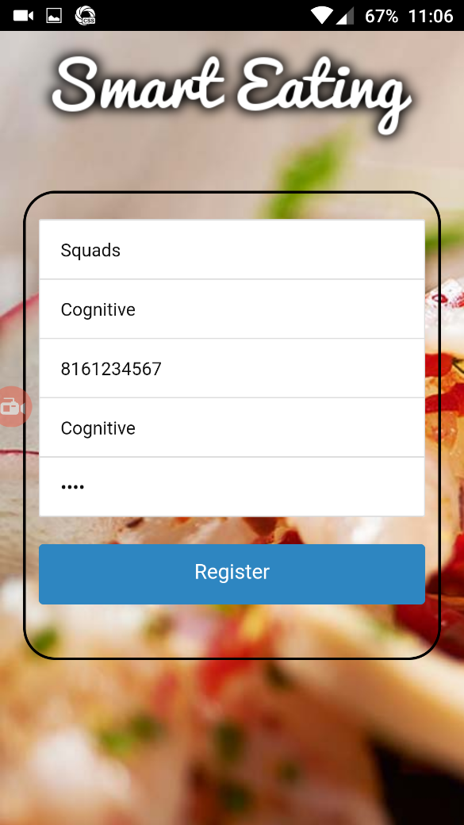

User Login:

In this page user is able to login into his account with the valid credentials.

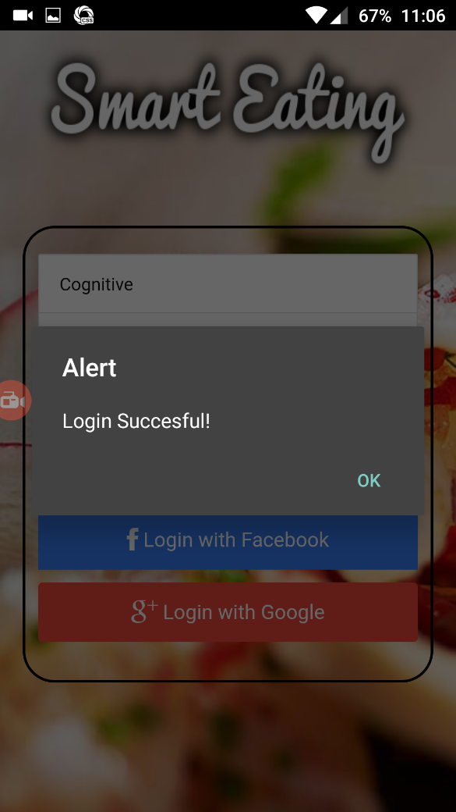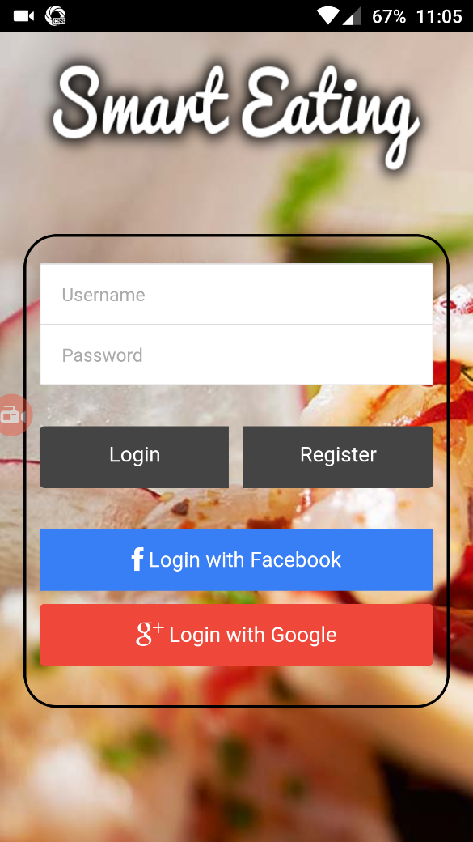

We will validate the user credentials, if they match the online database username and password it will give the user a successful login pop message and then redirected to the home page.

Home page:

In this page where user select search recipe or search restaurant to try new food.

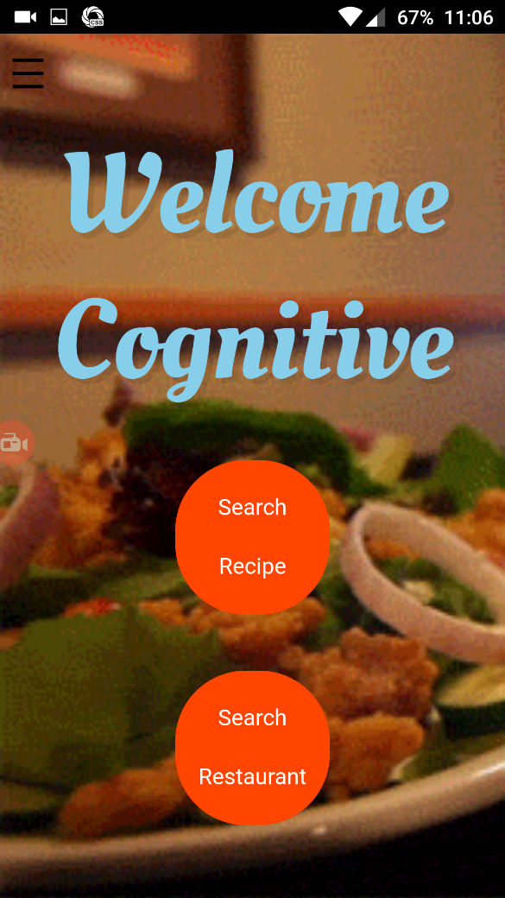 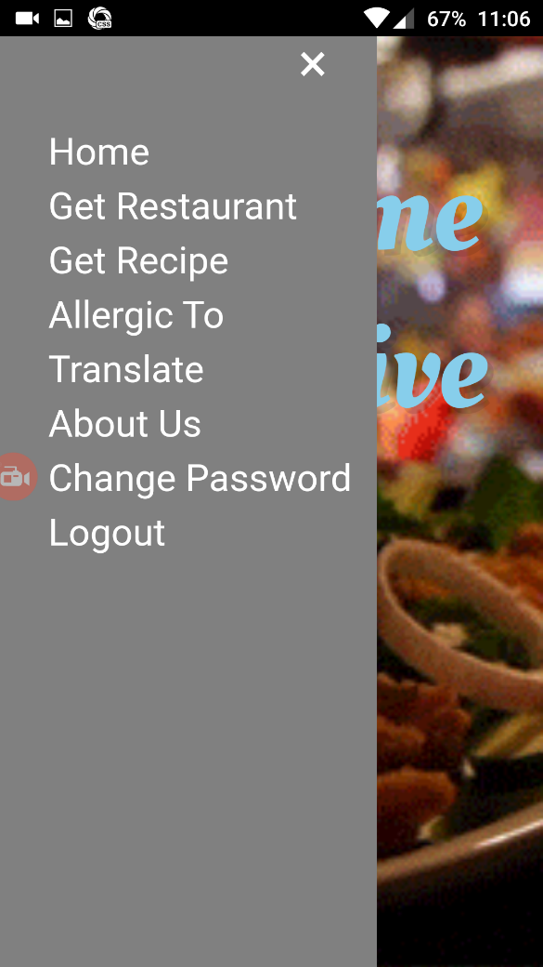

Search Recipe:

Here in this page user can search the food items to get their recipe’s

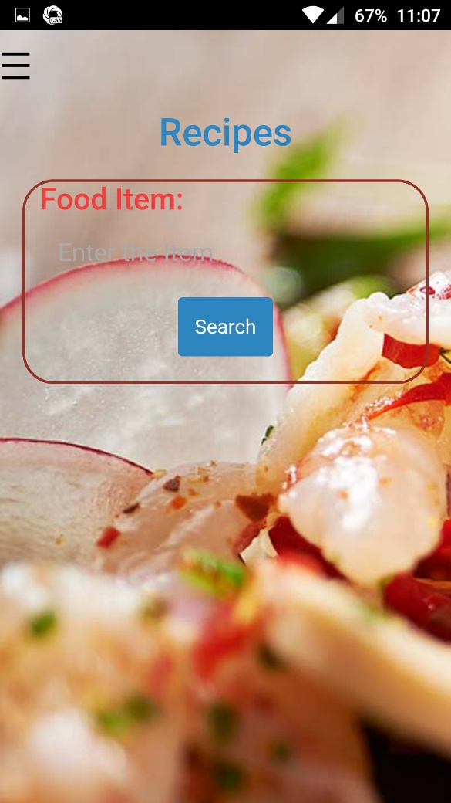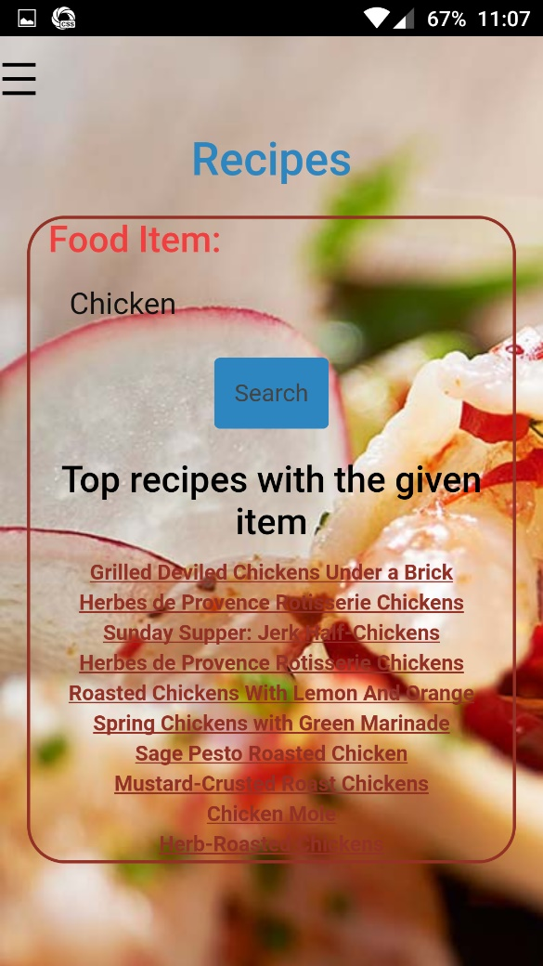

Ingredients Result :

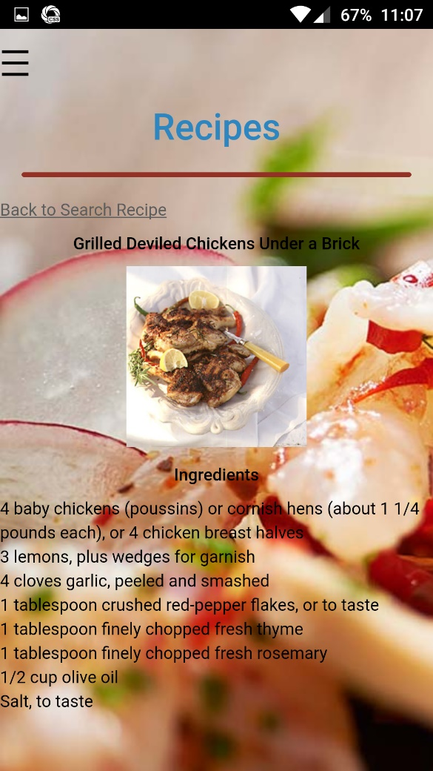

User can also get the images of the food items as well as the ingredients as shown above

Allergies :

In this page user can select the different items which are heshe allergic to.

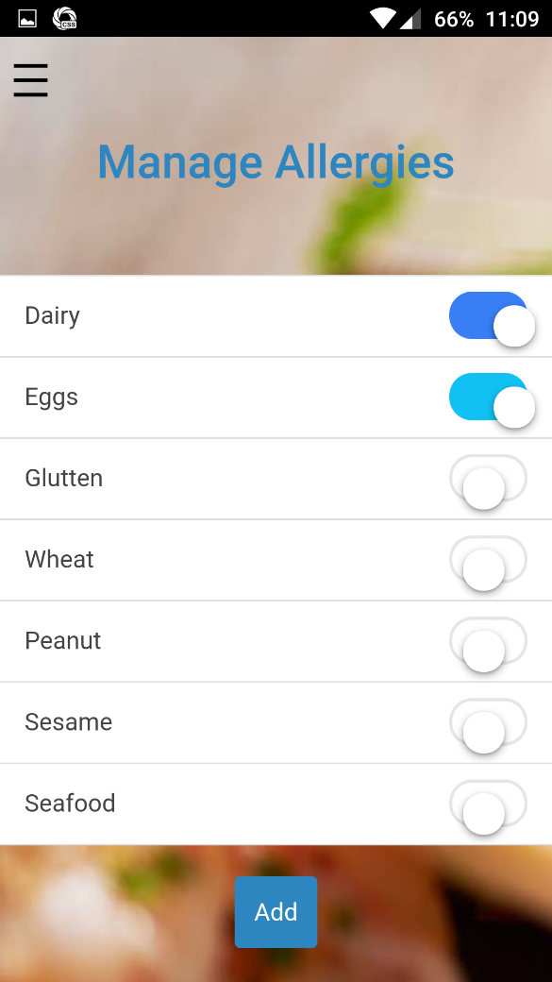

Restaurant Search:

Once he selects the place and which type of the food he wants to try we will display all the results related to the search field.

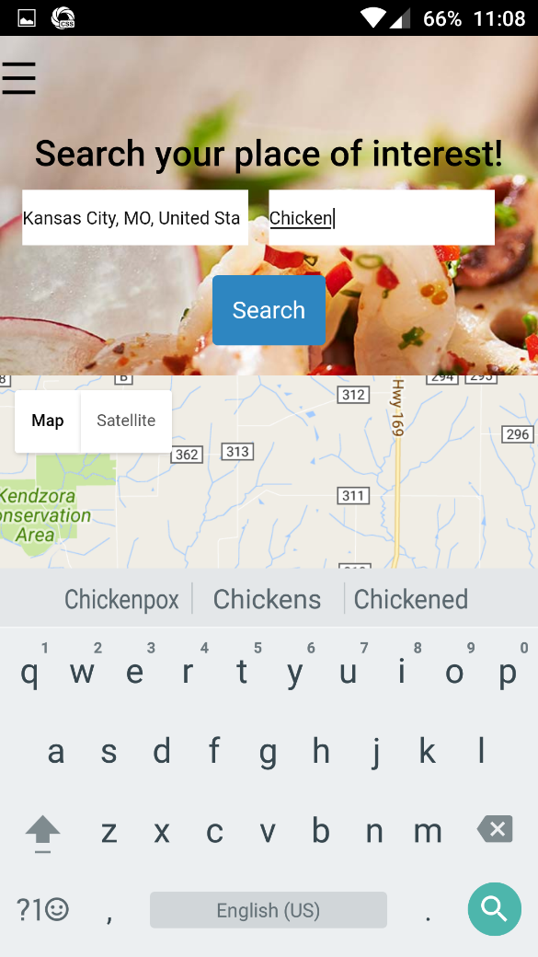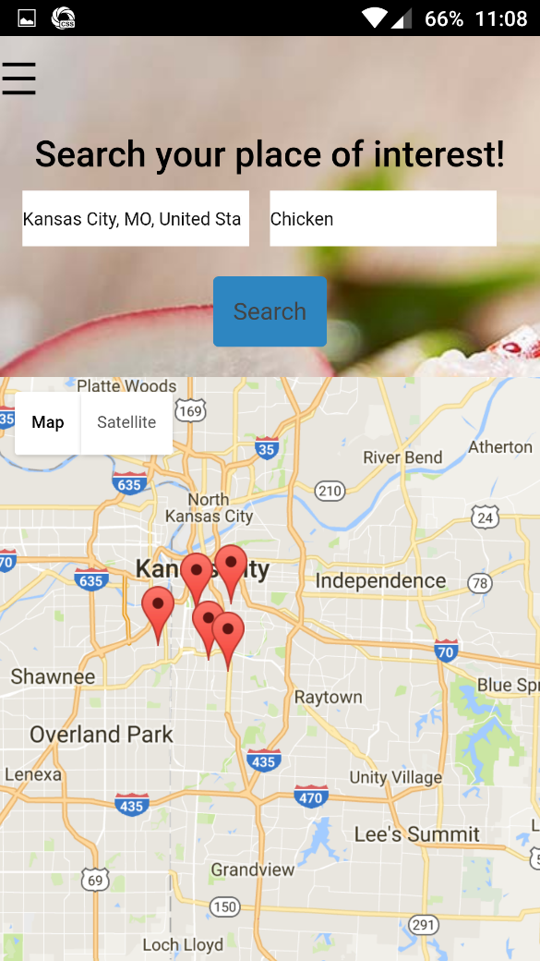

After getting the results we will display the restaurant name and menu and reviews from the previous users. Menu button will show the restaurant menu with the item names.

User Reviews/Menu : Here we will display the review of the food item from the previous customer.

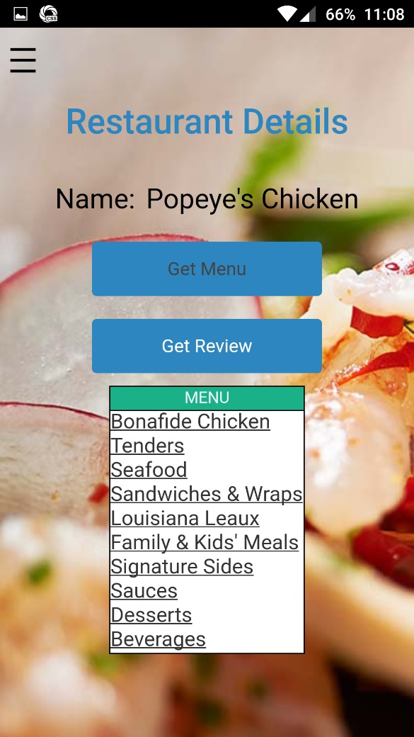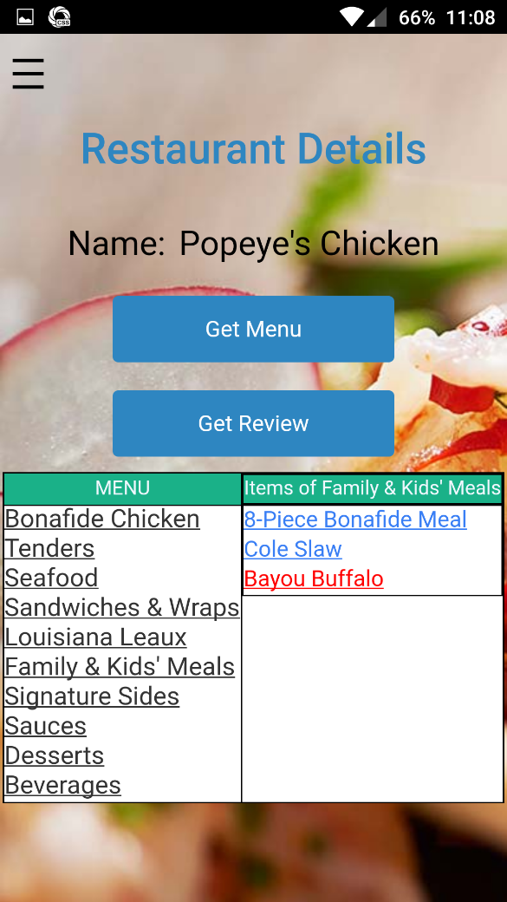

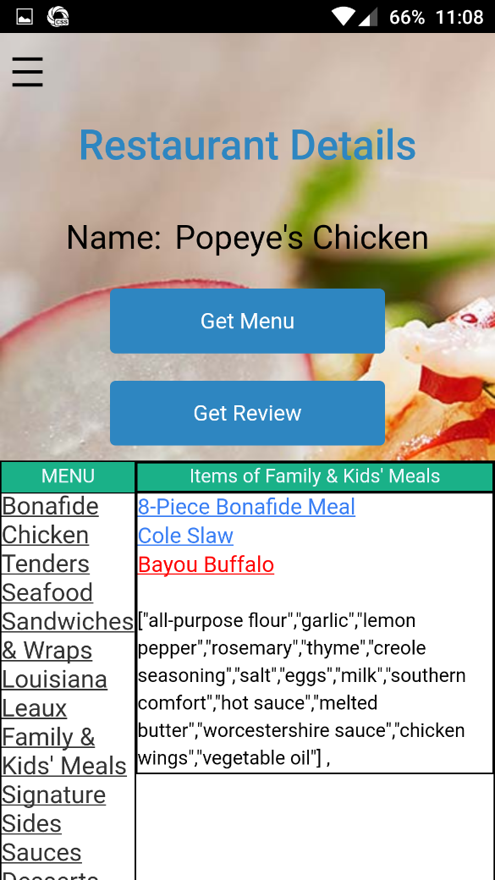

Translate page :

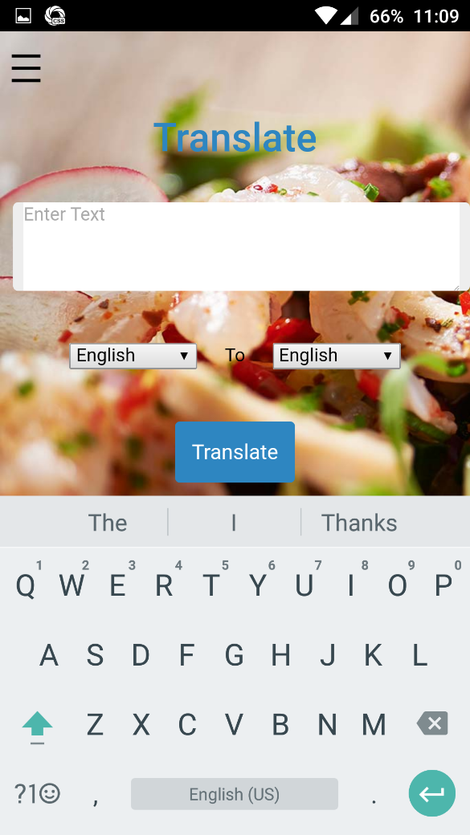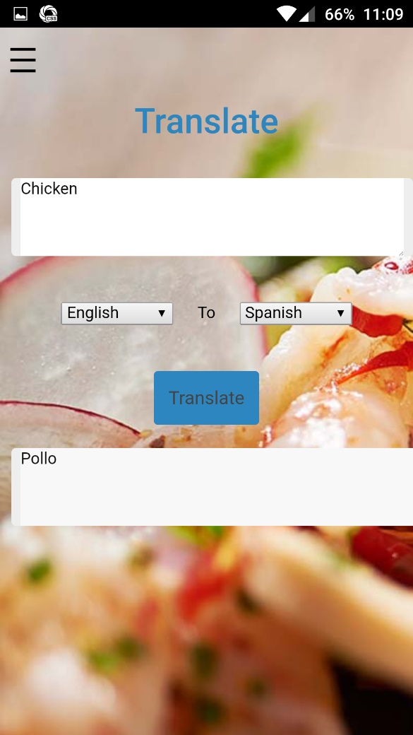

## **Web Application :**

we have deployed our application in web browser and android platform the web browser screen shoots are posted below android screen shots are posted already in above pages.

Web application login:

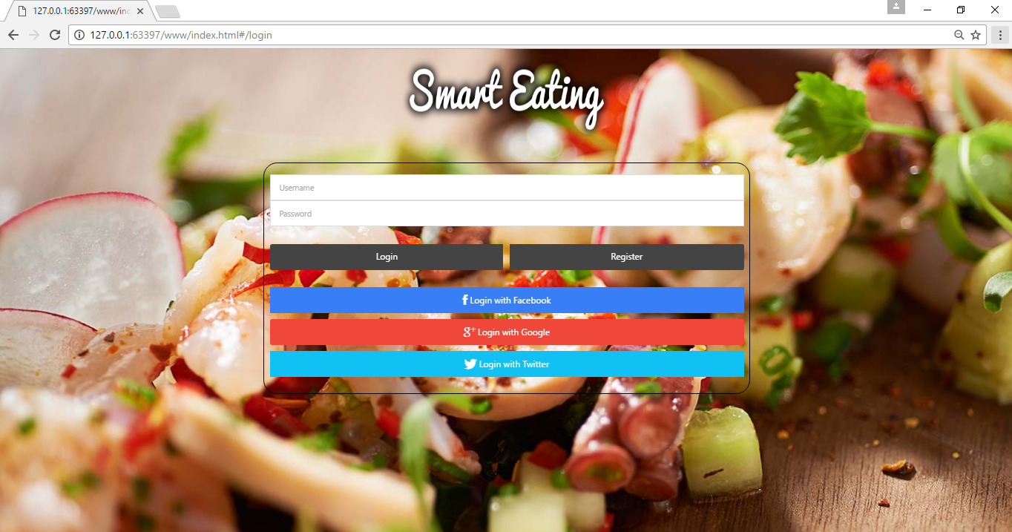

Home page:

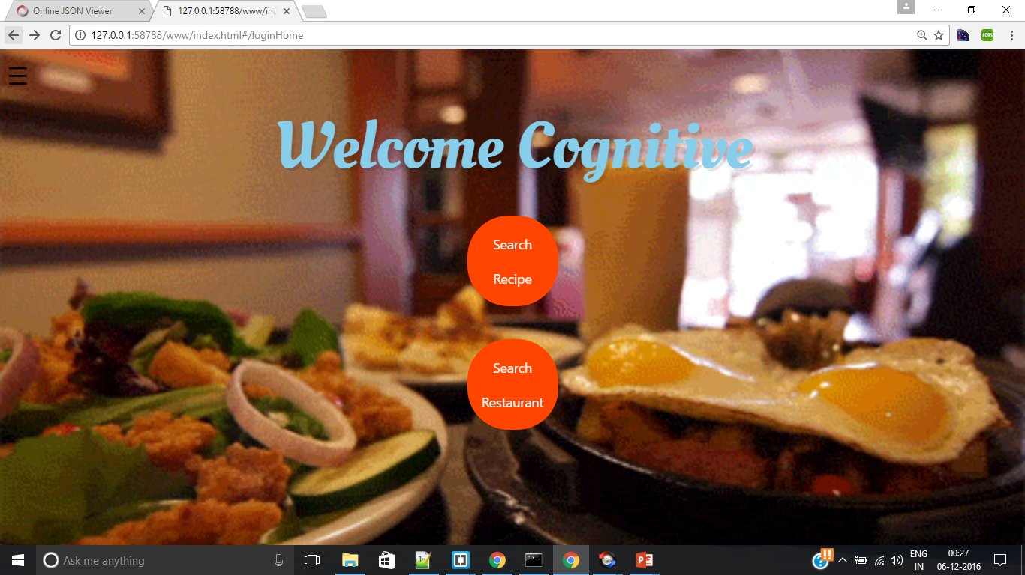

Search Recipe:

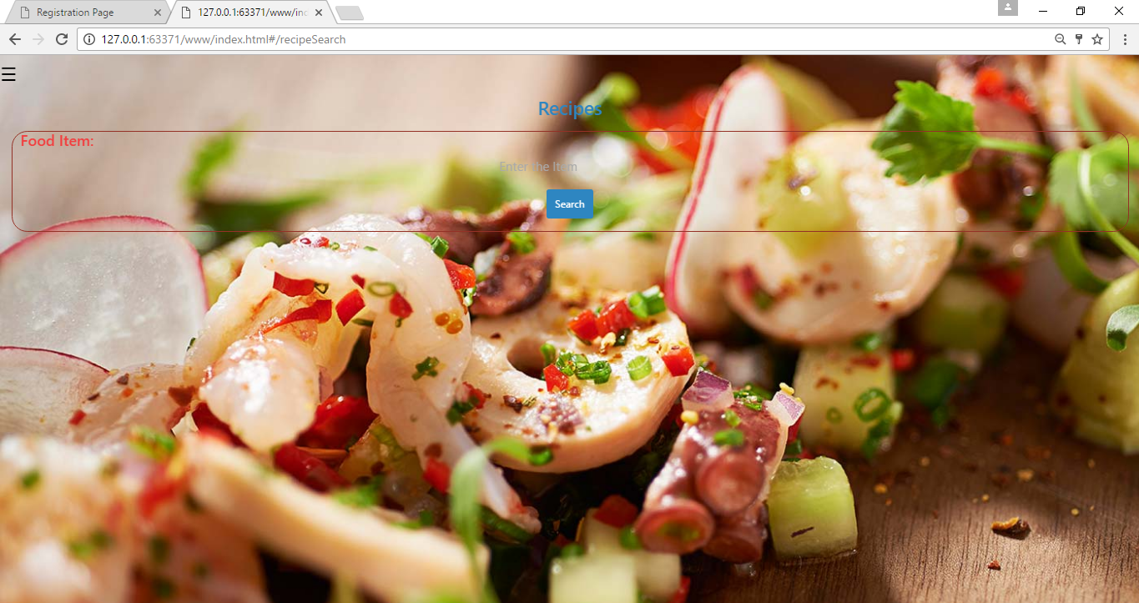

Search Restaurant:

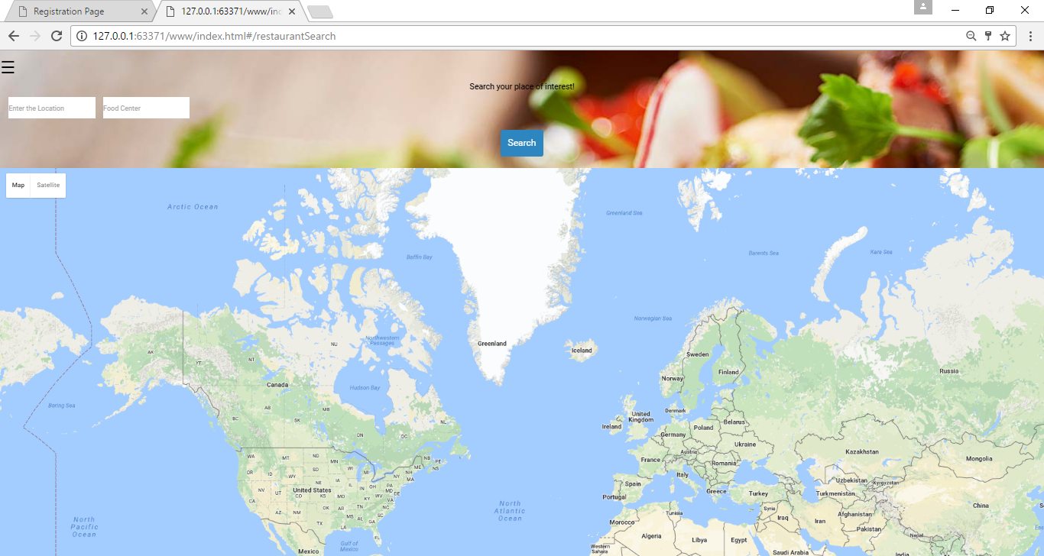

Side Menu :

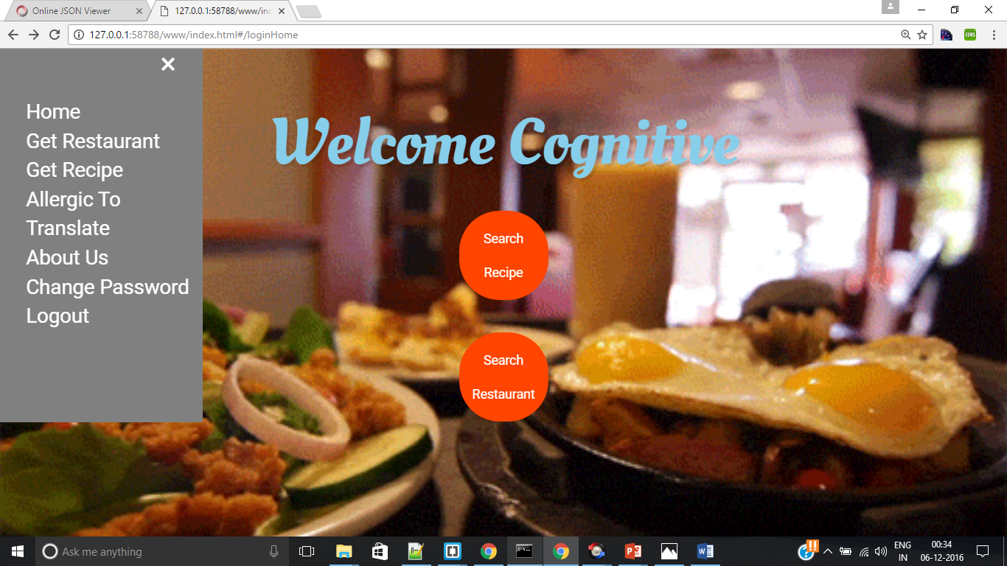

**Translate Page :**

